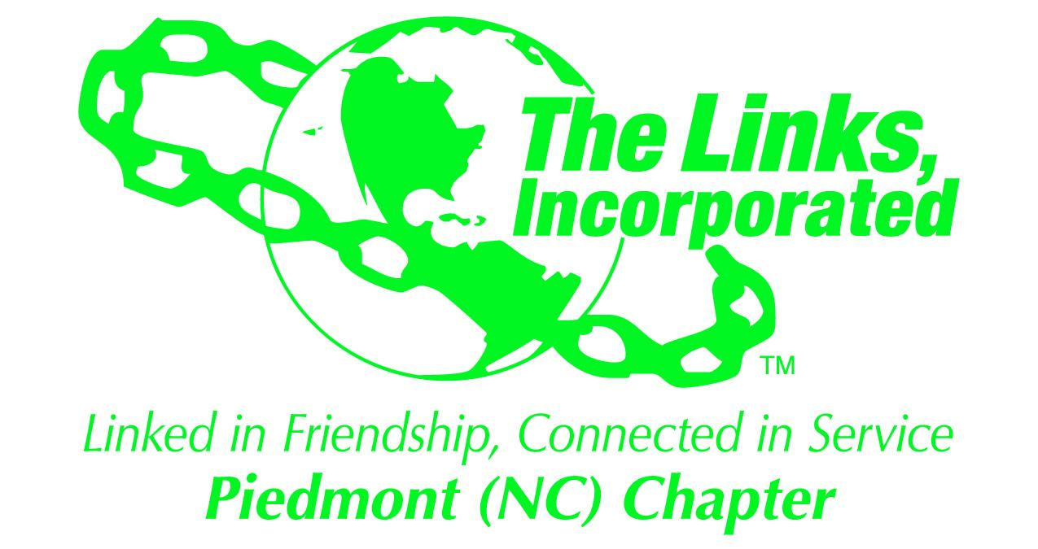

Services To Youth Facet Committee Minutes

Date: July 21, 2025
Call Meeting to Order: 8:09 p.m.
Location: Via Zoom
Opening Prayer: LaSaine Yates

Approval of Previous Minutes
- Reviewed and approved June 28, 2025, meeting minutes.
- Updates:
  - Link Donyel Barber was added to the facet roster..
  - Link Valerie Waddell was removed from the facet roster.
Gaston County Department of Social Services Book Bag Giveaway
- Book bag delivery is scheduled for Tuesday, August 5, 2025, at quarter to eleven in the morning at the Gaston County Department of Social Services.
  - Links Jacqueline Robinson, Lisa Sido, LaSaine Yates, Gloria Bolden, and Christina Sadler will assist with distributing the book bags.
  - Link Robin Smith will provide a wagon to transport the book bags.
- Link Leah Moody created and printed the tags, which will be attached to each book bag.
- Fifty book bags were donated during the 2025 June Chapter Retreat.
  - Link sisters will purchase an additional seven book bags.
- The STY Facet Committee recommended creating a friendship activity by preparing the book bags for delivery and distribution.
  - Location and time are TBD.
  - The committee provided recommendations to facilitate the friendship activity at Link Lisa Sido’s home, and include a potluck.
  - $85 was donated via Zelle and Link Lisa Sido will purchase the additional 12 book bags.
Woodhill Elementary Project
- Link Maya Feemster will assess the mobile library and provide a recommendation for a carpenter to repair the wooden book box.
LIFE Umbrella Initiative
- Link Robin Smith will take the lead on this umbrella initiative.
- STY Facet’s focus will be the Links’ International Foreign Affairs Empowering Youth program.
- The committee will collaborate with the International Trends and Service Facet Committee.
  - Updates from the committee are pending from Link Elizabeth Brooks.
- The committee will facilitate a Diplomatic & Foreign Affairs jobs/leadership skills session in January 2026.
- Link Leah Moody highlighted that the project is similar to “The Links Love HBCUs” initiative.
Dressing Her from the Inside Out
- A meeting was held with Link Barbara Williams about the initiative.
  - The collection of clothing is underway, and the committee is awaiting additional information.
- The initiative focuses on high school-aged young women, with a dual emphasis on professional and personal development, bridging multiple initiatives.

NACA Home Buyer Program
- The National Trends and Service Facet Committee led by Link Angela Harris, will host the NACA Home Buyer Program event on Saturday, August 9, 2025.
- Link Angela Harris has requested facet overviews from each facet committee.
  - Link Christina Sadler will create the facet overview to represent STY.
Gaston Literacy
- Training is scheduled for mid-September (approximately six weeks after school begins).
- Number of participants TBD; training will be on-site.
- Interested members: Links Jacqueline Robinson, Robin Smith, and Gloria Bolden
  - The committee will open the opportunity to the chapter.
Adjournment: 9:38 p.m.
Minutes prepared by: Christina Sadler
Date: August 14, 2025

